# Oracle 12c Installation and Configuration on RHEL 7.2

## Pre Installation Steps:

### Requirements:

* For large-scale installation we need to use multicore processors with High availability.
* Recommended minimum RAM needed for Oracle is 2GB or more.
* Swap must be enabled double the size of RAM.
* Disk space must be more than 8GB, it depends on edition which are we going to choose for installing.
* /tmp directory must have free space more than 1GB for error free installation.
* Supported Linux operating systems are RHEL, Centos, Oracle.
* Both x86_64 and i686 packages are required for installation.
* Screen resolution must be more than 1024×768 resolution.

If your system meets all the above requirements, then we are ready to move forward to start oracle installation.

Note: (Reference links followed for installation) Please remember, here it is used CentOS 6.5 operating system with 32GB size of Virtual HDD and 4GB Memory for installation, but same steps can also be followed in RHEL, Oracle Linux too.

Note: I strongly recommend you to use root login for all below installation instructions.

#### Here is the step by step procedure for setting up the pre requisites for Oracle 12c

**Step 1: Setting Hostname and Upgrading System**

1. Before, heading up for the installation process, first makes sure your / and /tmp partitions has enough available space to carry error free installation.

$ df –h

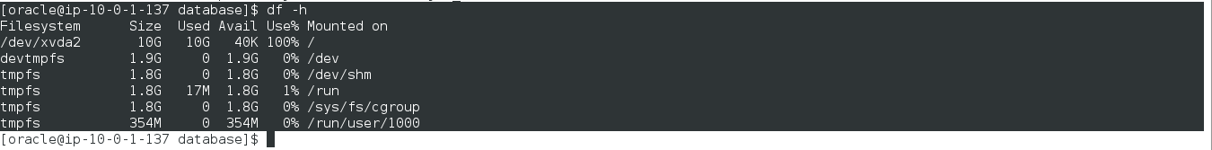

1. Next, verify that your system has correct hostname, static IP address and distribution version, using following commands.

$ hostname

$ ifconfig | grep inet

1. If you’ve not set your system hostname, edit the system hosts file ‘/etc/hosts‘ and enter your hostname entry along with IP address as shown below.

$ vi /etc/hosts

1. Now change the SELinux mode to permissive and restart the system to make Permanent changes for selinux.

$ sudo vi /etc/sysconfig/selinux

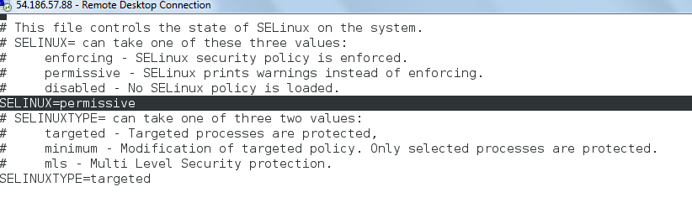

$ sudo init 6 // restart

#### Step 2: Installing Packages and changing Kernel Values

1. Once your system boots up properly, you can do a system upgrade and then install following required dependencies.

$ sudo yum clean metadata && sudo yum upgrade

$ sudo yum install binutils.x86_64 compat-libcap1.x86_64 compat-libstdc++-33.x86_64 compat-libstdc++-33.i686 \

compat-gcc-44 compat-gcc-44-c++ gcc.x86_64 gcc-c++.x86_64 glibc.i686 glibc.x86_64 glibc-devel.i686 glibc-devel.x86_64 \

ksh.x86_64 libgcc.i686 libgcc.x86_64 libstdc++.i686 libstdc++.x86_64 libstdc++-devel.i686 libstdc++-devel.x86_64 libaio.i686 \

libaio.x86_64 libaio-devel.i686 libaio-devel.x86_64 libXext.i686 libXext.x86_64 libXtst.i686 libXtst.x86_64 libX11.x86_64 \

libX11.i686 libXau.x86_64 libXau.i686 libxcb.i686 libxcb.x86_64 libXi.i686 libXi.x86_64 make.x86_64 unixODBC unixODBC-devel sysstat.x86_64

1. After installing all the above needed packages, now it’s time to do some changes at kernel level parameters in ‘/etc/sysct.conf file.

kernel.shmmax = 4294967295

kernel.shmall = 2097152

fs.aio-max-nr = 1048576

fs.file-max = 6815744

kernel.shmmni = 4096

kernel.sem = 250 32000 100 128

net.ipv4.ip_local_port_range = 9000 65500

net.core.rmem_default = 262144

net.core.rmem_max = 4194304

net.core.wmem_default = 262144

net.core.wmem_max = 1048576

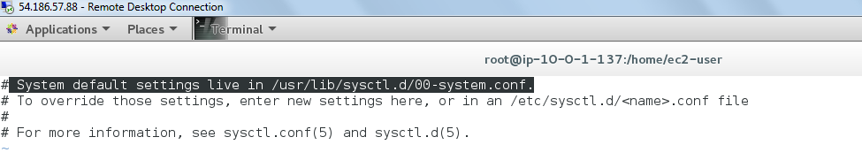

Therefore, go to the above highlighted location “/usr/lib/sysctl.d/00-system.conf”

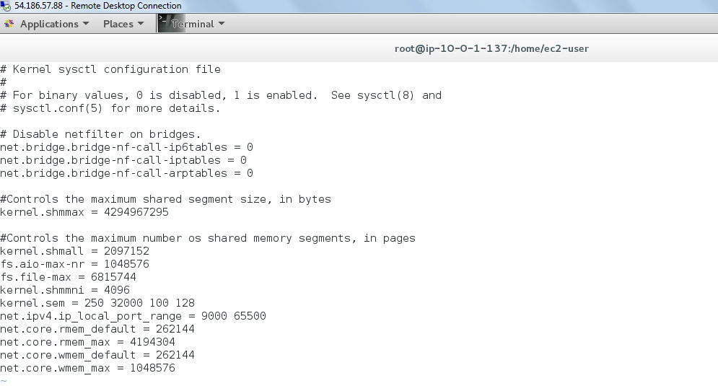

Add or change the following values as suggested. Save and quit using wq!.

1. Once you’ve added above values, now issue following command to take new changes into effect.

$ sysctl –a //SYSCTL –A

$ sudo init 6 // For a restart for the changes to take effect

Note: The above values are half the size of physical memory in bytes. For example, I have assigned 5GB memory for my virtual machine. So I’m using half of the memory for these settings. (According to the link in the reference used as a guide for installation)

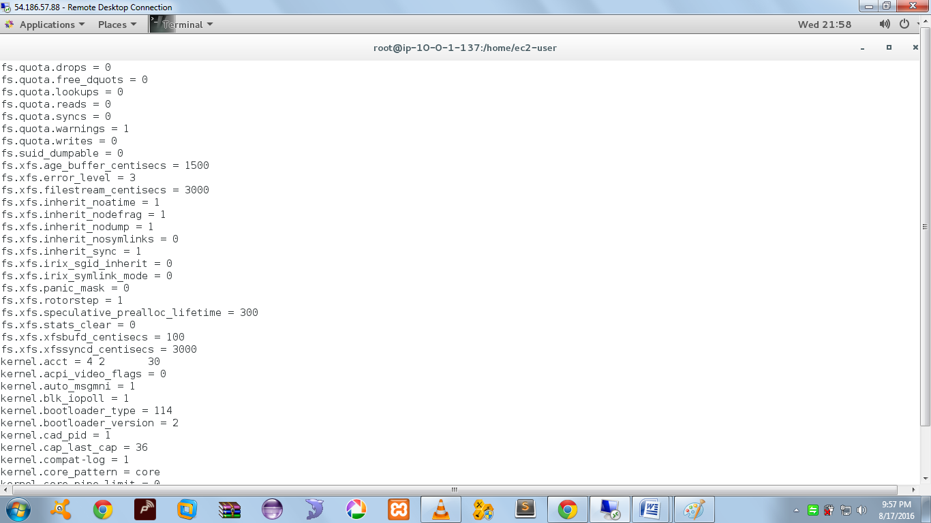

Demo Output for all the Kernel values updated

#### Step 3: Configuring System for Oracle Installation

1. Create the new groups Oracle inventory, OSDBA and OSOPER for Oracle installation.

$ sudo groupadd –g 54321 oracle

$ sudo groupadd –g 54322 dba

$ sudo groupadd –g 54323 oper

1. Create the new user oracle and add the user to already created groups.

$ sudo useradd -u 54321 -g oracle -G dba,oper oracle

$ sudo usermod -a -G wheel oracle

$ sudo passwd oracle

Note: It will ask for a password for oracle user, set it and retype it for confirming.

1. If your system is enabled with firewall, you need to disable or configure it according to your needs. To disable it, run the following commands.

$ sudo iptables -F

$ sudo service iptables save

$ sudo chkconfig iptables on

Note: Make sure you have the iptables-services package installed. This legacy package provides the systemd scripts for the previous iptables invocation. This package is not always installed, depending on your installation choices when you installed (or upgraded).

yum install iptables-services //IMPORTANT

And of course, if possible, you should use the new firewalld system. It should only be necessary to revert to the old system if firewalld fails to provide a feature you need.

**EXTRA**

firewall-cmd --add-service=http # Running config

firewall-cmd --add-service=http --permanent # Startup config

Later (post-RHEL 7) versions of firewalld do include a way to save the running configuration, and this is available now in Fedora and in RHEL 7.1. In this case the command is simply:

firewall-cmd --runtime-to-permanent

1. Create the following directory for installing Oracle and change the ownership and grand permission to the newly created directory using recursive.

$ sudo mkdir -p /u01/app/oracle/product/12.1.0/db_1

$ sudo chown -R oracle:oracle /u01

$ sudo chmod -R 775 /u01

$ ls -l /u01

1. Switch to root user to create environment for oracle user. You can skip this step, if you’re already using root login.

$sudo – root // skip if already in root

1. Next, we need to add the environmental variable for oracle user. Open and edit the profile file of oracle user and append the oracle environment entries. Here we don’t need to use sudo command, as we are already logged in as root user.

$ vi /home/oracle/.bash_profile

// Add the following entries

## Oracle Env Settings

export TMP=/tmp

export TMPDIR=$TMP

export ORACLE_HOSTNAME=oracle12c.tecmint.local

export ORACLE_UNQNAME=orcl

export ORACLE_BASE=/u01/app/oracle

export ORACLE_HOME=$ORACLE_BASE/product/12.1.0/db_1

export ORACLE_SID=orcl

export PATH=/usr/sbin:$PATH

export PATH=$ORACLE_HOME/bin:$PATH

export LD_LIBRARY_PATH=$ORACLE_HOME/lib:/lib:/usr/lib

export CLASSPATH=$ORACLE_HOME/jlib:$ORACLE_HOME/rdbms/jlib

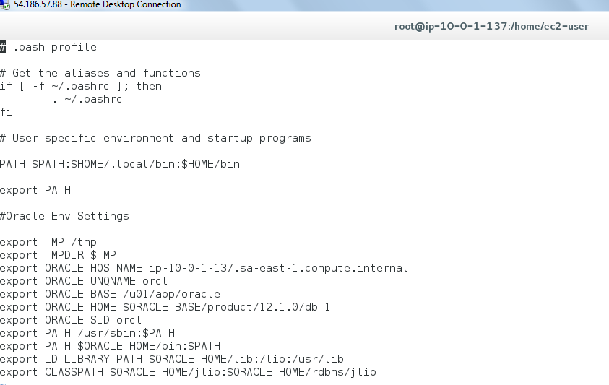

1. Now exit from root user and login again and switch to oracle user. Again, this step is not required, if you are already using root account, just switch to oracle user for further instructions.

$ exit

$ sudo – oracle

1. Here we need to check for the resource limits for oracle installing user. Here our Oracle installer user is oracle. So we must be logged in as oracle user, while doing resource check. Check for the soft and hard limits for file descriptor settings before installation.

$ ulimit -Sn

$ ulimit -Hn

$ ulimit -Su

$ ulimit -Hu

$ ulimit -Ss

$ ulimit –Hs

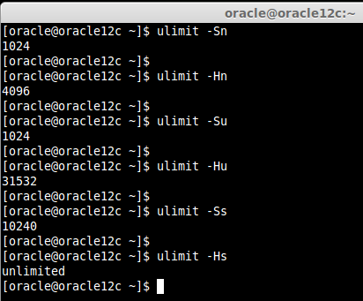

// Demo output, we might get different values.

1. We need to manually assign the values for limits in configuration file as shown below.

$ sudo vim /etc/security/limits.conf

oracle soft nofile 1024

oracle hard nofile 65536

oracle soft nproc 2047

oracle hard nproc 16384

oracle soft stack 10240

oracle hard stack 32768

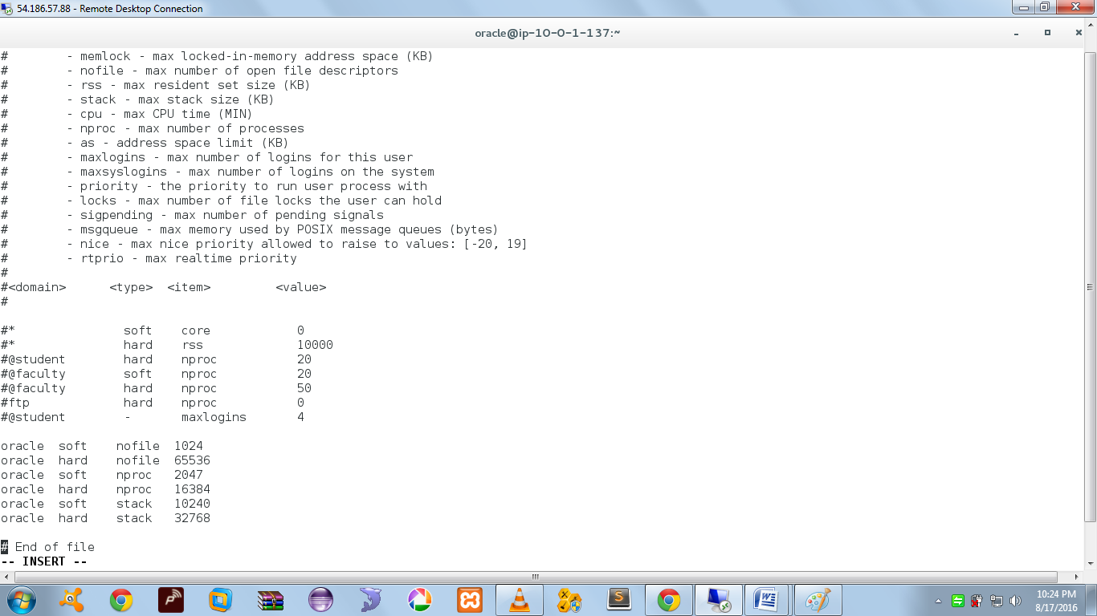

1. Next, edit the below file to set the limit for all users.

$ sudo vim /etc/security/limits.d/90-nproc.conf

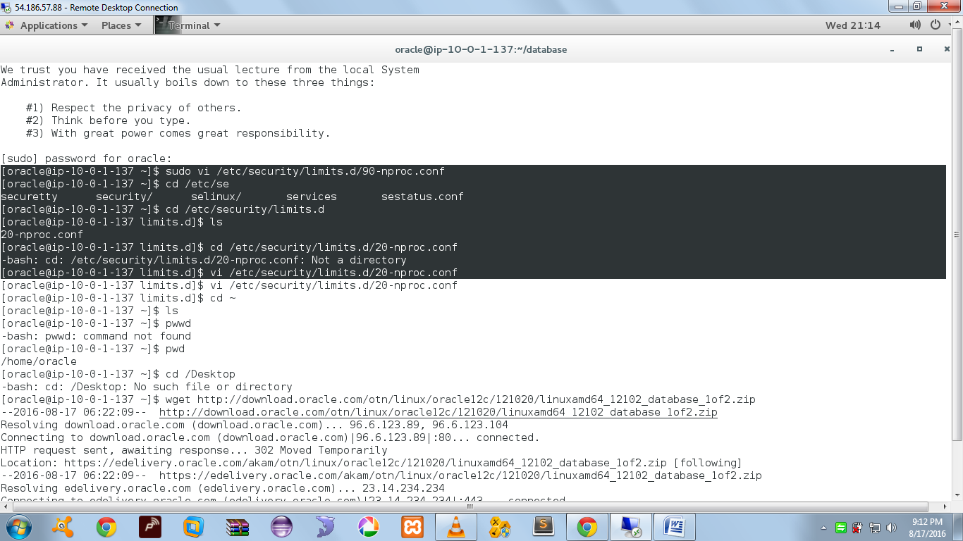

// Error while accessing 90-nproc.conf because in RHEL the name of the file is 20-nproc.conf

Default : * soft nproc 1024

Change to : * - nproc 16384

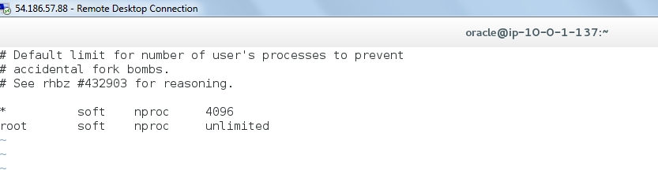

#### Step 4: Downloading Oracle Packages

1. Then it is time to pull down the oracle zip package from official site. To download Oracle package, you must be registered user or else sing-up and download the package using the below link.

$ cd ~

$ ls

$ unzip linuxamd64_12c_database_1of2.zip

$ unzip linuxamd64_12c_database_2of2.zip

#### Installing Oracle 12c Database in RHEL 7.x

1. After extracting, we will get database directory which has 2.6GB in size. So, next we can go-head and install the oracle. Let us start the installation by running runInstaller. Navigate the installer Directory and run the Installer.

$ cd database/

$ ./runInstaller

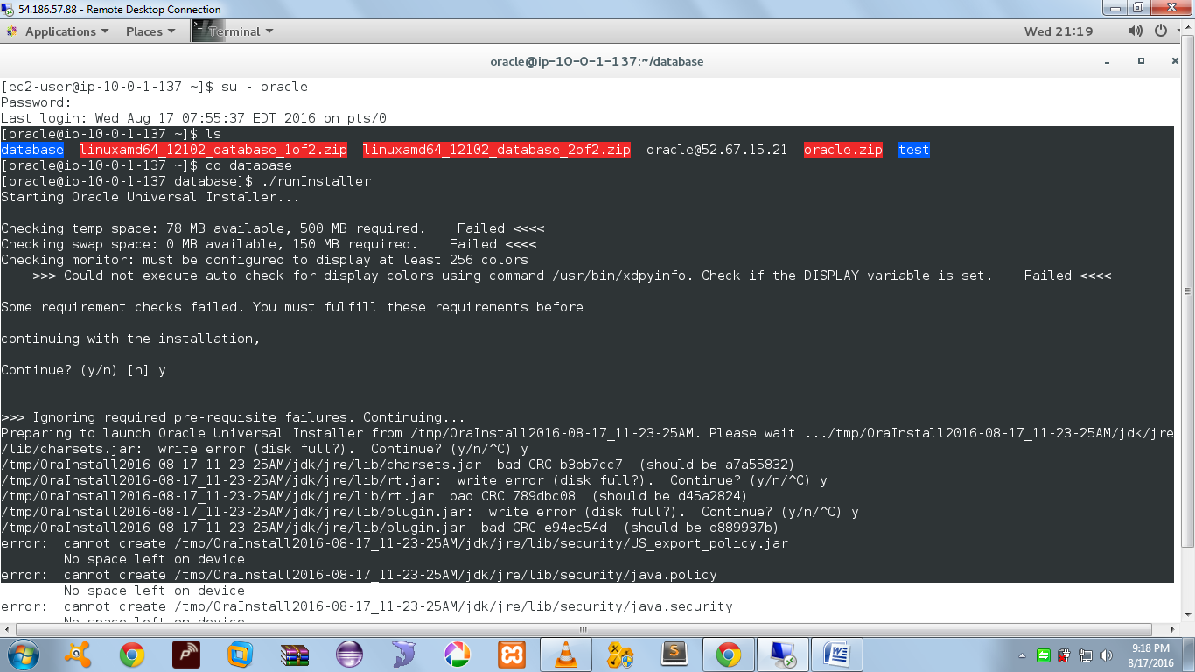

**Error Stack :**

Starting Oracle Universal Installer...

Checking temp space: 78 MB available, 500 MB required. Failed <<<<

Checking swap space: 0 MB available, 150 MB required. Failed <<<<

Checking monitor: must be configured to display at least 256 colors

>>> Could not execute auto check for display colors using command /usr/bin/xdpyinfo. Check if the DISPLAY variable is set. Failed <<<<

Some requirement checks failed. You must fulfill these requirements before

continuing with the installation,

Continue? (y/n) [n] y

>>> Ignoring required pre-requisite failures. Continuing...

Preparing to launch Oracle Universal Installer from /tmp/OraInstall2016-08-17_11-23-25AM. Please wait .../tmp/OraInstall2016-08-17_11-23-25AM/jdk/jre/lib/charsets.jar: write error (disk full?). Continue? (y/n/^C) y

/tmp/OraInstall2016-08-17_11-23-25AM/jdk/jre/lib/charsets.jar bad CRC b3bb7cc7 (should be a7a55832)

/tmp/OraInstall2016-08-17_11-23-25AM/jdk/jre/lib/rt.jar: write error (disk full?). Continue? (y/n/^C) y

/tmp/OraInstall2016-08-17_11-23-25AM/jdk/jre/lib/rt.jar bad CRC 789dbc08 (should be d45a2824)

/tmp/OraInstall2016-08-17_11-23-25AM/jdk/jre/lib/plugin.jar: write error (disk full?). Continue? (y/n/^C) y

/tmp/OraInstall2016-08-17_11-23-25AM/jdk/jre/lib/plugin.jar bad CRC e94ec54d (should be d889937b)

error: cannot create /tmp/OraInstall2016-08-17_11-23-25AM/jdk/jre/lib/security/US_export_policy.jar

No space left on device

error: cannot create /tmp/OraInstall2016-08-17_11-23-25AM/jdk/jre/lib/security/java.policy

**Ref erences:**

1. **Installation**
2. <http://www.tecmint.com/setting-up-prerequisites-for-oracle-12c-installation/>
3. <http://www.tecmint.com/oracle-12c-installation-in-centos-6/>
4. **Issue with verification of key**

<http://rafudb.blogspot.in/2015/10/installing-oracle-12102-on-red-hat-7.html>

1. **sysctl changes (iptables)**
2. <http://www.cyberciti.biz/faq/rhel-centos-linux-7-restart-networking-command-line/>
3. <https://www.certdepot.net/rhel7-use-sysctl/>
4. <http://serverfault.com/questions/674874/is-there-a-way-to-run-just-save-with-firewalld-in-rhel7>